1. 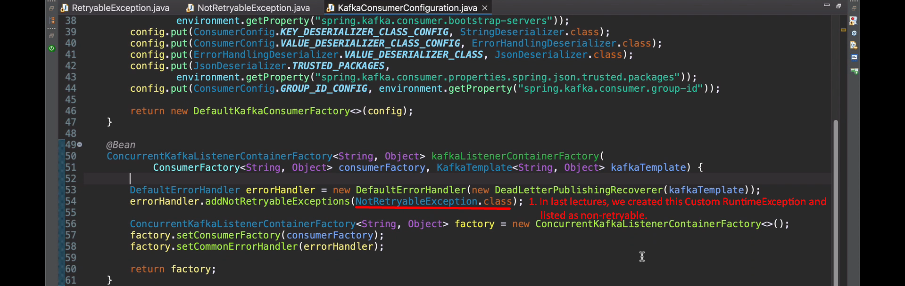
2. 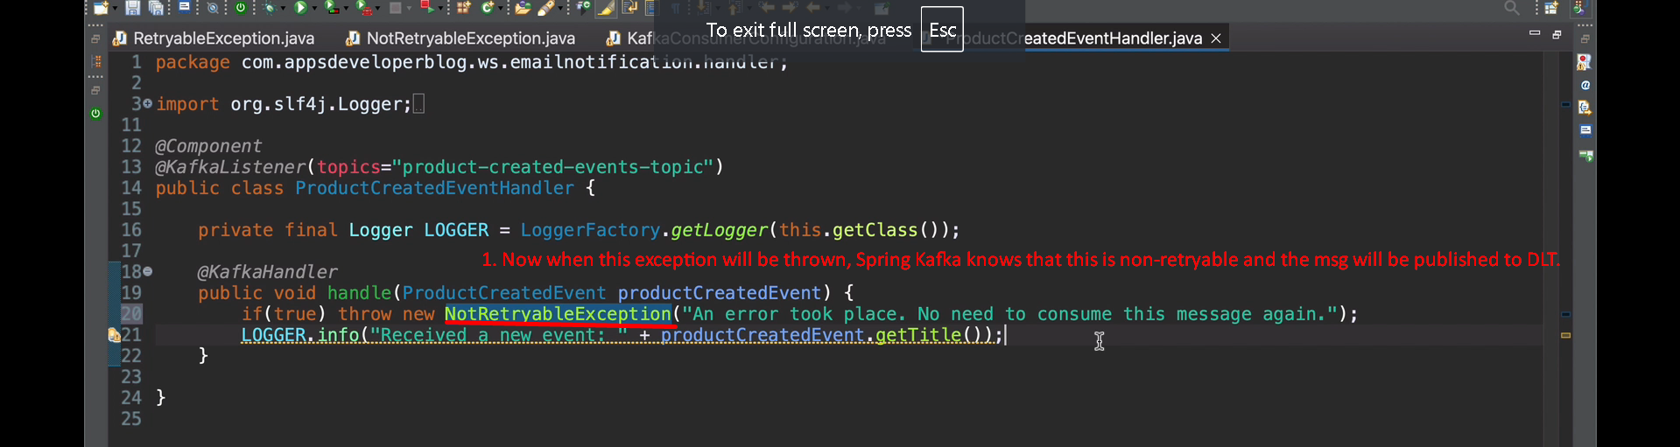
3. Let’s try to send one valid msg to Broker.
4. 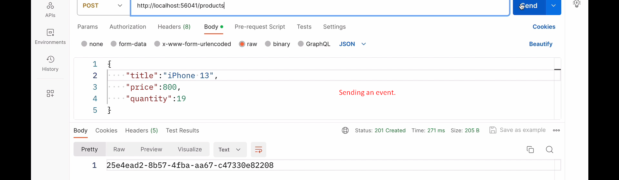
5. 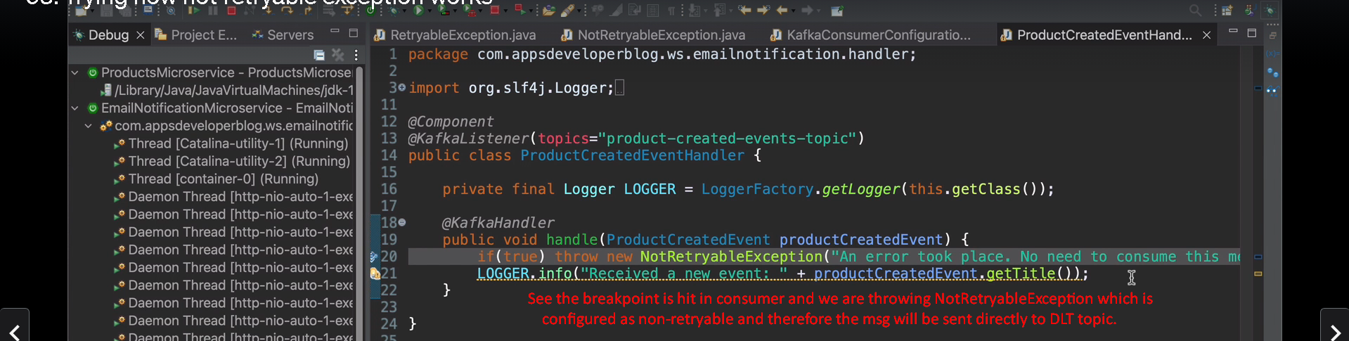
6. 